Forward engineering – QSEE

1. Create your ERD and include your attributes in the entity. Plan carefully data types and sizes for each column.
2. Identify pk for each table. Think of a need for NN and UNIQUE constraints as well.
3. Don’t include FKs on the diagram!

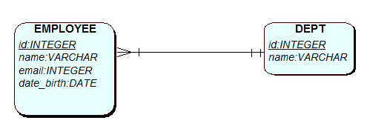

Steps to produce DDL for the tables:

1. Find SQL button Screen Clipping, top
2. Click on it and select yes to generate

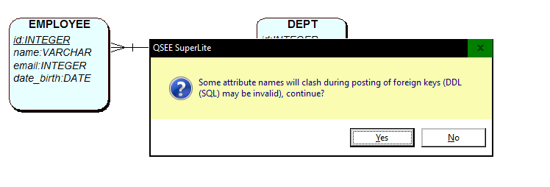

1. Select where to save the file

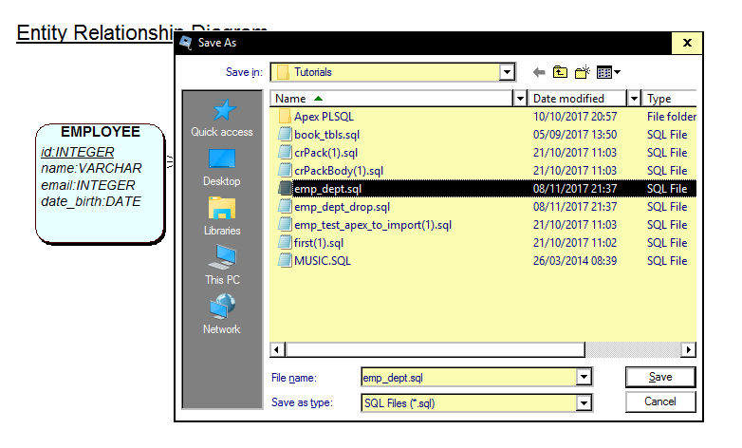

1. Follow instructions, select yes…

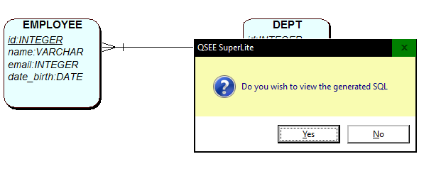

1. Two SQL files will be created – one for drop tables, one for create tables… merge them into one.

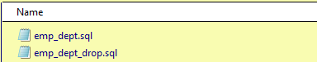

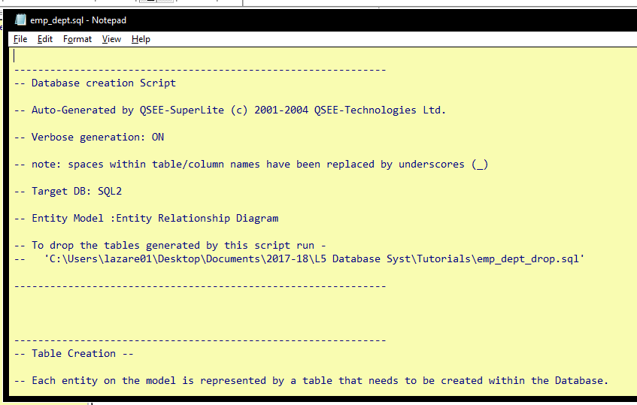

1. Copy DROP table commands from the other script, and add CASCASDE CONSTRAINTS to both tables.
2. In your DDL script, from the ALTER table you need to remove ON DELETE RESTRICT ON UPDATE RESTRICT.

ALTER TABLE EMPLOYEE ADD CONSTRAINT fk1_EMPLOYEE_to_DEPT FOREIGN KEY(fk1_id) REFERENCES DEPT(id);

1. Save you script and go to Apex Scripts, upload the script (following standard instructions) and run the code.
2. Check tables in OB.
3. Next step is to insert test data. You should do it in the script. No need to do it for this task.